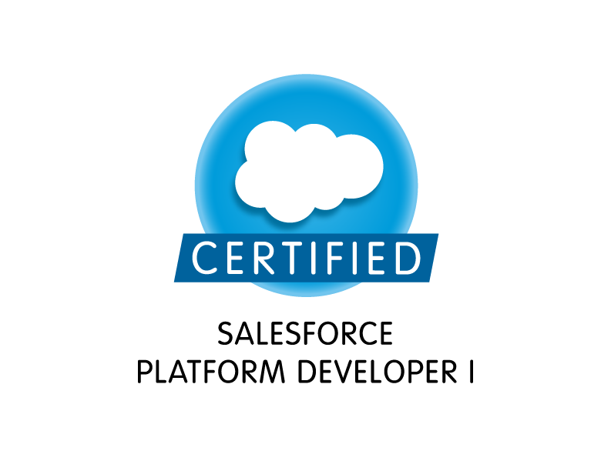
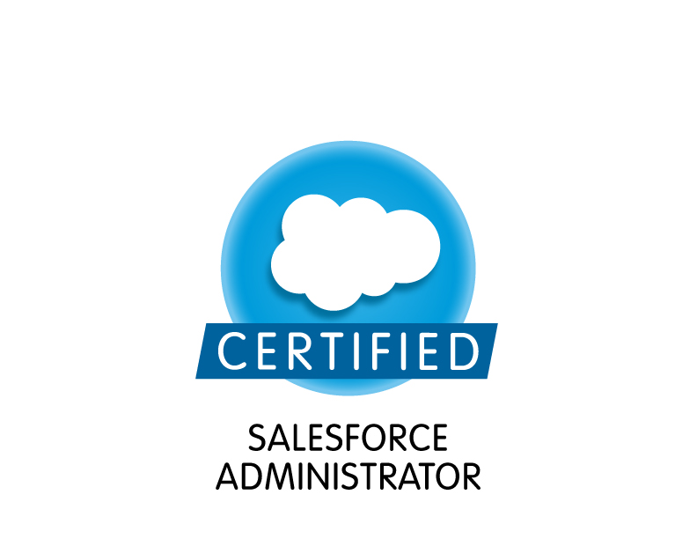
Rani

Professional Summary:
- Around 9 years of experience in IT industry with around 6 years of experience in the Salesforce.com CRM both as Administrator and Developer in Salesforce.com Sales, Marketing, Customer Service and Support Administration.
- Over 2 of experience as Java/J2EE Developer that includes Analysis, Design and Development, Testing, Implementation, production support and maintenance of various Applications.
- Experienced in Salesforce.com Apex Classes, Apex triggers Integration, VisualForce, Force.comAPI. Hands on experience in Salesforce.com CRM integration, developing and deploying custom integration solutions.
- Extensive experience in designing of custom objects, custom fields, Picklist, role based page layouts, Workflow Alerts & Actions, Approval Workflows, Validation Rules, Approval Processes, Custom Tabs, Custom reports, Report folders, report extractions to various formats, design of Visualforce Pages, Snapshots, Dashboards, and Email generation according to application requirements.
- Experience in Java, J2EE, C# ,HTML, CSS, JQuery, XML, UML, JavaScript, Agile, N-tier Architecture, Webservices and SOAP and Identify Management.
- Good working experience in querying Salesforce.com database using SOQL&SOSL queries using Force.com Explorer.
- Strong experience in creating executive dashboard to display Open, closed leads in Salesforce.com.
- Good Experience in developing Custom Page Layouts, work flows, and Approval processes.
- Experience with data migration and updates through the tool App Exchange Data Loader in Salesforce.com and Salesforce Lightening.
- In-depth understanding of the capabilities and constraints of the SFDC CRM application.
- Experience in installing Salesforce AppExchange Apps, configured and maintained user security permissions in compliance with organizational needs.
- Well versed in cloud technology and on-premise infrastructure integration for Salesforce.com using Force.com platform, XML, Web Services (WSDL) and third party packages.
- Experience in implementing Enterprise applications using Java, EJB, JSP, Servlets, JDBC, JMS, Web Services, JavaScript, XML and HTML.
- Excellent experience in using Oracle 8i/9i,SQL Server 2000 and SQL databases and Familiar with Stored procedures, Triggers and Functions using PL/SQL.
- Deployment experience using Force.com IDE and change sets as well as hands on Sandbox management experience.
- Highly proficient with Sales Cloud, Service Cloud, Marketing cloud, Community Portal, Site.com, Reporting.
- Proficient in authoring Business Requirement Documents (BRD) into System Requirement Specifications (SRS) and identifying interface and business process specifications.
- Competent in analyzing and creating Narrative Use Cases, Use Case Diagrams, Activity diagrams, Class diagrams, Data/Flow/Navigational flow diagram using UML Tools like MS Visio.
- Understanding of all phases of SDLC and software development methodologies like Agile, Waterfall etc.
- Hands on experience in implementing Apttus CLM.
- Expertise in Business Analysis methodologies and iterative Software Development Life Cycle (SDLC) in relation with all the phases of Rational Unified Process (RUP).
- Participated in Weekly Change control meetings and performed application and global impact analysis.
- Hands on experience using Quality center to initiate a new project, log defects and store documents.
- Hands on experience using SAML 2.0 SSL in Salesforce CRM.
- Highly motivated team player with excellent communication, presentation and interpersonal skills. Willing to work in a challenging and cross-platform environment.

Technical Skills:

Salesforce  technologies | Salesforce CRM, Salesforce SFA, Apex Language, Apex Classes/Controllers, Apex Triggers, SOQL, SOSL, Lightening, Visualforce Pages /Components, S Controls, Apex Web Services, AJAX, Workflow & Approvals, Dashboards, Analytic Snapshots, Case Management Automation, Custom Objects, Apex Data Loader
Salesforce Tools | Eclipse, Force.com Eclipse IDE Plug-in, Force.com Explorer, Force.com Data Loader, Force.com Excel Connector, Foorce.com Platform
Languages | Apex, C, C++, Java, J2EE, JSP, Java Script, .NET, Action Script, UML, HTML, XML, TML,SQL,CSS
Operating Systems | Windows NT / 2000 / Vista, Windows Server 2000/2003/2008, UNIX, Sun Solaris 9

Professional Experience:

Cardinal Health Inc, Dublin, OH August 2015 - Present
Role: Senior Salesforce Developer

Responsibilities:
- Interacted with various business team members to gather the requirements and documented the requirements.
- Experienced in working across various SFDC implementations of Service Cloud and Chatter.
- Worked as a Sales Force Chatter APP with the organization and regularly participated in the meetings and chatter community.
- Implemented several security assessment policies to identify problems in the databases.
- Implementation of a custom partner community using visual force and lighting components projects.
- Created custom controllers implementing complex code for retrieval from SalesForce to VF pages.
- Wrote SOQL and SOSL statements within custom controllers, extensions and triggers.
- Always wrote test methods with code coverage of 80-100%.
- Supported the data migration activities from various business centers and business center user.
- Used field level security along with page layouts to manage access to certain fields.
- Used SAML 2.0 based SSO for building task flow for reducing the number of steps.
- Used Force.com developer toolkit including Apex Classes, Apex Triggers and Visualforce pages to develop custom business logic.
- Expanded deployment for customer service reps, partner portal users, and customer portal users
- Designed and deployed Custom tabs, validation rules, Approval Processes and Auto-Response Rules for automating business logic.
- Used Force.com developer toolkit including Apex Classes, Apex Controllers and ApexTriggers to develop custom business logic.
- Responsible for designing presentation tier using html, xml, CSS, Java Script.
- Developed several custom reports to better assist managers and also report folders to provide report accessibility to appropriate personnel.

Environment: Salesforce.com, Force.com Sandbox, Lightening, S-Controls, Import Wizard, Apex, XML, HTML5, CSS Controllers, Sharing rules,JavaScript,Controllers, Visual Force Pages, Workflows, Web Services API, Java Script, Custom Objects, Custom Tabs.

AT&T, NJ Oct 14 – July 15
Role: Salesforce Developer

Responsibilities:
- Participated in Joint Application Development (JAD) sessions to identify business rules and requirements and then documented them in a format that can be reviewed and understood by both business and technical teams.
- Involved in deploying the CRM tool Salesforce.com to include: business requirement development, dashboard development, report & list view development, process flows and documentation.
- Created Custom Objects and fields for transactional and contractual information.
- Designed and deployed Custom tabs, validation rules, Approval Processes and Auto-Response Rules for automating business logic.
- Implemented Salesforce Lightning Components for small set of users within the organization.
- Implemented Service Cloud for customer service, including configuration of email to case, case assignment rules. Managed migration and release of Service Cloud.
- Created modules for Pretrial, Day Reporting Centre, and Community Corrections.
- Conduct Identity Management workshop to understand Clients requirement & propose appropriate solution.
- Identified and resolved problems, which may impact projects by monitoring progress and project status.
- Created workflow rules and defined related tasks, email alerts, and field updates.
- Implemented pick lists, dependent pick lists, lookups, master detail relationships, validation and formula fields to the custom objects.
- Created page layouts, search layouts to organize fields, custom links, related lists, and other components on record pages.
- Used field level security along with page layouts to manage access to certain fields.
- Used Force.com developer toolkit including Apex Classes, Apex Triggers and Visualforce pages to develop custom business logic.
- Implemented Web Services for integrating internal non-SFDC systems to update relevant fields in Salesforce.com pages/objects.
- Used the sandbox for testing and migrated the code to the deployment instance after testing.
- Integration experience to consume data from MDM systems as required.
- Involved in the Data Transformation and Data Cleansing activities while transferring the data to the external system using Informatica On-Demand.
- Worked on Campaign/Lead management integration between Eloqua and Salesforce.

Environment: Eclipse IDE, Salesforce.com, Force.com Sandbox, Lightening, Import Wizard, Apex, XML, CSS, JavaScript, Controllers, Sharing Rules, Visualforce Pages, Workflows, Email Updates, .NET Framework, Web Services API, Oracle EBS, Oracle on Demand, Oracle Fusion Middleware, SOA, Siebel, People Soft, MDM, Eloqua.

Client: Carlyle Group, Arlington, VA Jun 2013 – Sep 2014
Role: Sr. Sales force Developer

Responsibilities:
- Performed the roles of Salesforce.com Developer and Administrator in the organization.
- Interacted with various business user groups for gathering the requirements for Salesforce.com CRM implementation.
- Leveraging Sales Cloud functionality, including Account Planning, Sales Forecasting, Opportunity Management and Lead Management.
- Involved in Salesforce.com Application Setup activities and customized the apps to match the functional needs of the organization.
- Created Custom objects, custom fields, Picklist, role based page layouts, Workflow Alerts and Actions, and Approval Workflow, Validation Rules, Approval Processes, custom Tabs, custom reports, report folders, report extractions to various formats, design of Visualforce Pages, Snapshots, Dashboards, and Email generation according to application requirements.
- Implemented the requirements on Salesforce.com platform and Force.com IDE Plug-in using Eclipse.
- Worked with various Salesforce.com objects like Accounts, Contacts, Leads, Campaigns, Reports, and Dashboards.
- Developed Apex Classes, Controller Classes and Apex Triggers for various functional needs in the application.
- Developed various Custom Objects, Tabs, Components and Visualforce Pages.
- Developed and configured various Custom Reports and Report Folders for different user profiles based on the need in the organization.
- Developed Custom Objects, Custom Reports and configured the Analytic Snapshots to dump the data on regular basis for the sales performance and lead generation statistics.
- Maintained user roles, security, profiles, and workflow rules wherever necessary.
- Interacted with the Salesforce.com premium tech support team on a regular basis.

Environment: Saleforce.com platform, Apex Language, Visualforce Pages, Data Loader, HTML, CSS, Java Script, Workflow & Approvals, Reports, Custom Objects, Custom Tabs, Email Services, Sandbox data loading, Eclipse IDE Plug-in.

Level 3 Communications, Denver, Colorado April 2012 - May 2013
Role: Salesforce Developer

Responsibilities:
- Involved in Salesforce.com application setup activities and customized the apps to match the functional needs of the organization.
- Interacted with various business team members (JAD Sessions) to gather the requirements and documented the requirements.
- Worked with various Salesforce.com objects like Accounts, Contacts, Leads, Campaigns, Reports, Dashboards
- Developed various Custom Objects, Tabs, Components and Visualforce Pages.
- Create and Customize Custom Objects, Formula Fields, Cross Object Formulas, Roll up summary fields, validation rules, dependent picklists and complex page layouts.
- Create complex workflows and Approval processes.
- Implemented Data segregation through Record Types and Field level security.
- Developed and maintained validation rules and custom workflow.
- Used eclipse Force.com toolkit for creating Apex Classes and Apex Triggers to develop custom logic and objects.
- Audited, uncovered and resolved data integrity issues with legacy systems.
- Complete bulk imports of data using Apex DataLoader.
- Developed and maintained custom reports.
- Batch reassignment of accounts and opportunities based on organizational changes.
- Prepared training materials for business use.

Environment:Saleforce.com platform, Apex Language, Visualforce Pages, Data Loader, HTML, Java Script, Workflow & Approvals, Reports, Custom Objects, Custom Tabs, Email Services, Sandbox data loading, Eclipse IDE Plug-in.

Bank of America, Dallas, TX May 2011 – March 2012
Role: Salesforce Developer

Responsibilities:
- Involved in Salesforce.com Application Setup activities and customized the apps to match the functional needs of the organization.
- Worked with various salesforce.com objects like Accounts, Contacts, Cases, Activities, Reports and Dashboards.
- Developed various Custom Objects, Tabs, Components, VisualForce Pages and Controllers.
- Developed and customized console view.
- Developed Custom Objects, Custom Reports for the sales performance and lead generation statistics.
- Developed Apex Classes, Controller Classes and Apex Triggers for various functional needs in the application.
- Developed workflows, assignment rules, escalation rules, case teams, support settings, custom settings and other inbuilt functionality.
- Implemented Bulk API using java application for loading data from external systems.
- Created and used Email templates in HTML and Visualforce.
- Integrated the web services by generating the necessary stubs from the WSDL files for external applications and also integrated with multiple other systems to Sales force.
- Performed the roles of Salesforce.com Analyst/ Developer and Administrator in the organization.
- Interacted with the Salesforce.com premium tech support team on a regular basis.

Environment:Saleforce.com platform, Apex Language, Visual Force (Pages, Component & Controllers), Pages, Data Loader, Bulk API HTML, Java Script, and Change sets, Workflow & Approvals, Reports, Custom Objects, Custom Tabs, Email Services.

AIG, NJ June 2010 – April 2011
Role: Salesforce Developer/Administrator

Responsibilities:
- Involved in Salesforce.com Application Setup activities and customized the apps to match the functional needs of the organization.
- Implemented the requirements on Salesforce.com platform and Force.com IDE.
- Worked with various salesforce.com objects like Accounts, Contacts, Opportunities, Cases, Activities, Knowledge, Reports and Dashboards.
- Developed various Custom Objects, Tabs, Components, VisualForce Pages and Controllers.
- Developed and customized console view.
- Developed Custom Objects, Custom Reports and configured the Analytic Snapshots to dump the data on regular basis for the sales performance and lead generation statistics.
- Created and deployed Several Reports using salesforce.com platform.
- Developed Apex Classes, Controller Classes and Apex Triggers for various functional needs in the application.
- Developed workflows, assignment rules, escalation rules, case teams, support settings, custom settings and other inbuilt functionality.
- Created and used Email templates in HTML and Visual force.
- Integrated the web services by generating the necessary stubs from the WSDL files for external applications and also integrated with multiple other systems to Sales force.
- Performed the roles of Salesforce.com Analyst/ Developer and Administrator in the organization.
- Interacted with the Salesforce.com premium tech support team on a regular basis.

Environment:Saleforce.com platform, Apex Language, Visual Force (Pages, Component &Controllers), Pages, Data Loader, HTML, Java Script, Change sets, Workflow & Approvals, Reports, Custom Objects, Custom Tabs, Email Services, Security Controls, Sandbox data loading.

Wachovia Corporation, CA. Aug 2007 – May 2010
Role: Java/J2EE Developer

Responsibilities:
- Involved in Requirements and impact analysis.
- Preparation of technical High level and Low level design documents and coding.
- Preparation and execution of Unit Test Plans.
- Participated in defect prevention discussions and root cause analysis meetings
- Implemented JavaScript validations for the UI fields.
- Development of various utility classes to provide an application wide methods for common tasks
- Involved in Unit, Integration and Acceptance testing.
- Development of the Data Access Layer with JDBC calls.
- Used Oracle 9i database for tables creation and involved in SQL’s to query and retrieve the data from the Database.
- Identified and developed a reusable component that was well received by business and resulted in saving of very significant number of person hours.

Environment: Struts, Servlets2.0, JSP2.3, Java, XLM, Web Services, RAD 6.0, Web Sphere 6.0, Oracle9i, Radien Framework

